

LAB REPORT 1

SUBMITTED BY M SALEH HAYAT

SUBMITTED TO MAM MUNEEBA MUBARAK

CLASS BSCS-V-B

REG NO 232201070

SUBJECT COMPUTER ARCHITECTURE (LAB)

DATE 7/10/2025

Definition:
An OR gate is a digital logic gate that gives output 1 (HIGH) if at least one input is 1, otherwise output is 0 (LOW).
Truth Table (2-input OR Gate):
A | B | A | B
0 | 0 | 0
0 | 1 | 1
1 | 0 | 1
1 | 1 | 1

Verilog code of OR gate:
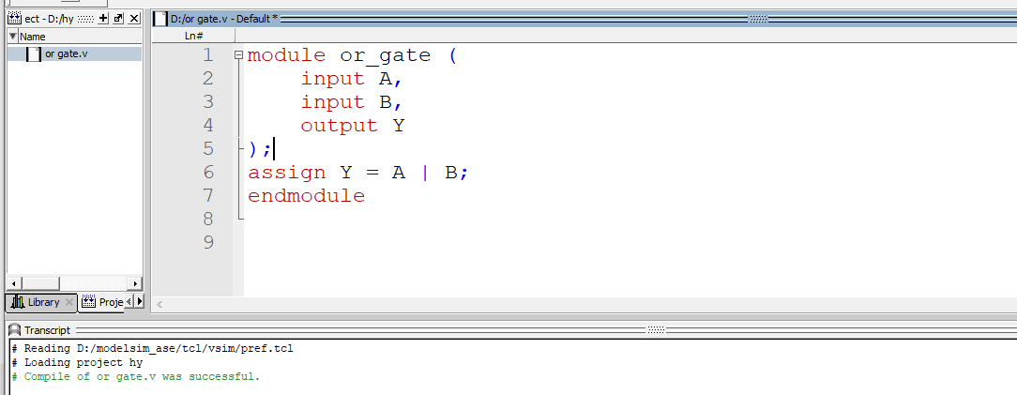
SIMPULATION OF VERILOG OF OR GATE:

TESTBENCH CODE OF OR GATE
TESTBENCH CODE OF OR GATE:
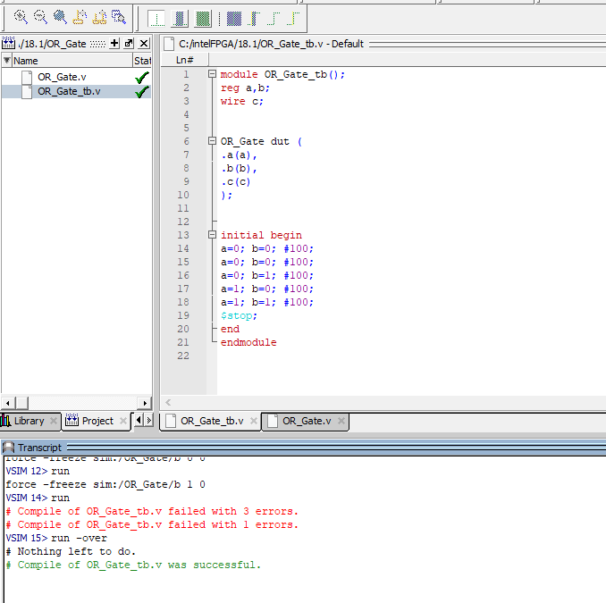

SIMULATION OF TESTBENCH OF OR GATE:

Definition of AND Gate
An AND gate is a digital logic gate that gives output 1 (HIGH) only when all inputs are 1. If any input is 0, the output will be 0.
Truth Table (2-input AND Gate)
A | B | A.B
0 | 0 | 0
0 | 1 | 0
1 | 0 | 0
1 | 1 | 1

Verilog code of AND gate:
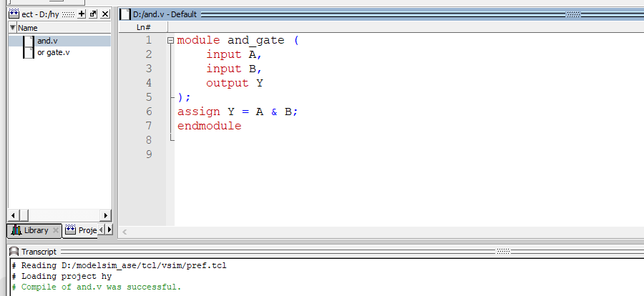
SIMULATION OF VERILOG OF AND GATE:

TESTBENCH CODE OF AND GATE:
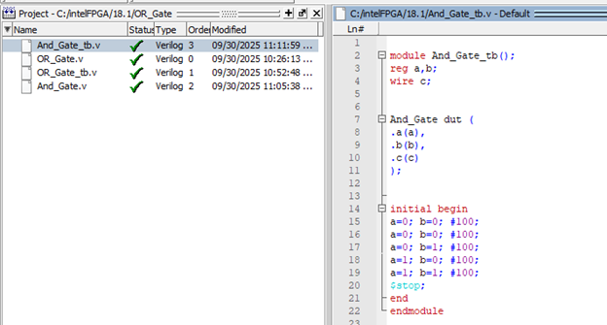
SIMULATION OF TESTBENCH OF AND GATE:
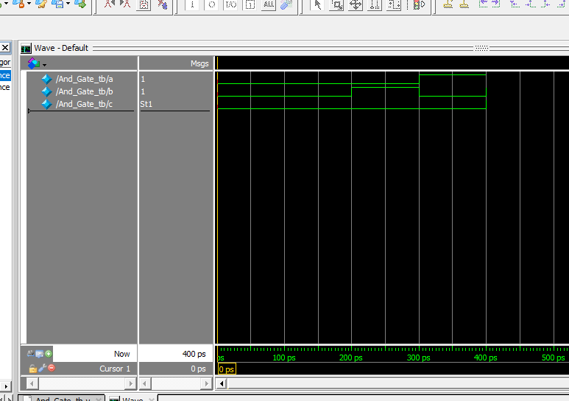

Definition of NOT Gate:
A NOT gate (also called Inverter) is a digital logic gate that inverts the input signal.
- If the input is 0, the output is 1.
- If the input is 1, the output is 0.
A | Y = Ā
0 | 1
1 | 0
Truth Table (2-input AND Gate):

VERILOG CODE OF NOT GATE:
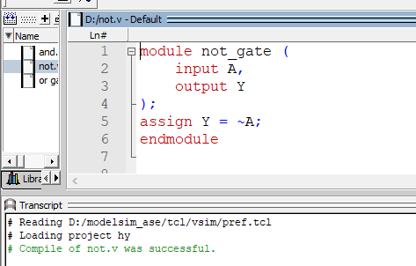
SIMULATION OF VERILOG OF NOT GATE:

TESTBENCH CODE OF NOT GATE:
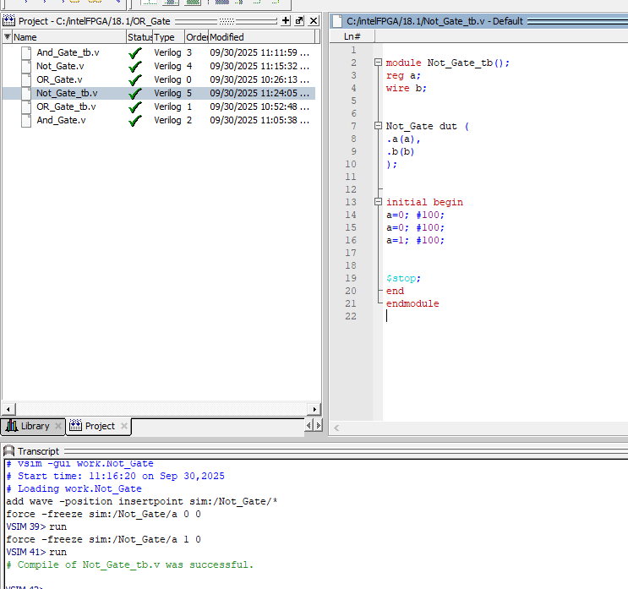
SIMULATION OF TESTBENCH CODE OF NOT GATE:
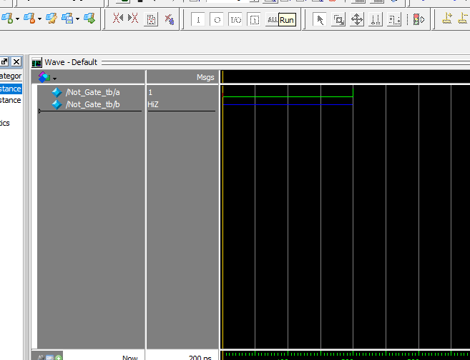

Definition of NAND Gate:
A NAND gate is a universal digital logic gate. It produces output 0 (LOW) only when all inputs are 1; otherwise, the output is 1 (HIGH).
It is the complement of the AND gate.
Truth Table (2-input NAND Gate):
A | B | Y = (A · B)′
0 | 0 | 1
0 | 1 | 1
1 | 0 | 1
1 | 1 | 0
VERILOG CODE OF NAND GATE
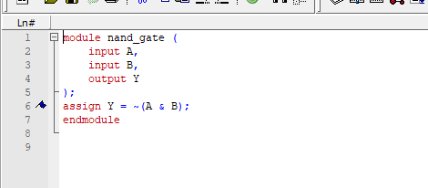
SIMULATION OF VERILOG OF NAND GATE:

TESTBENCH CODE OF NAND GATE:
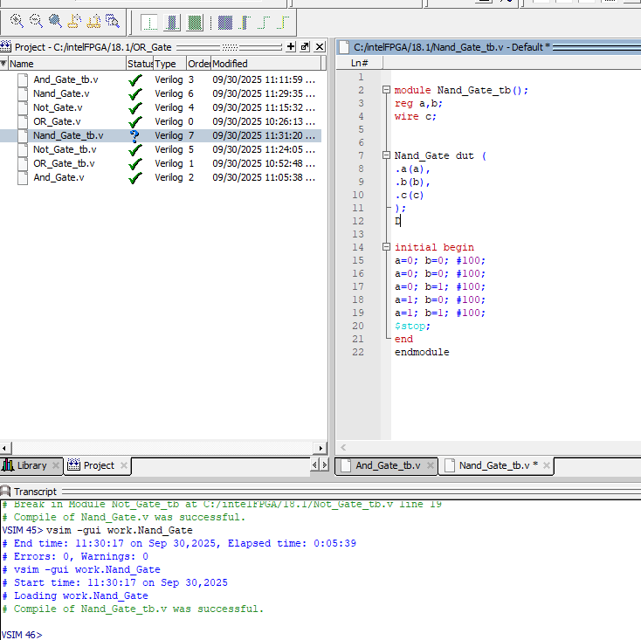
SIMULATION OF TESTBENCH OF NAND GATE:
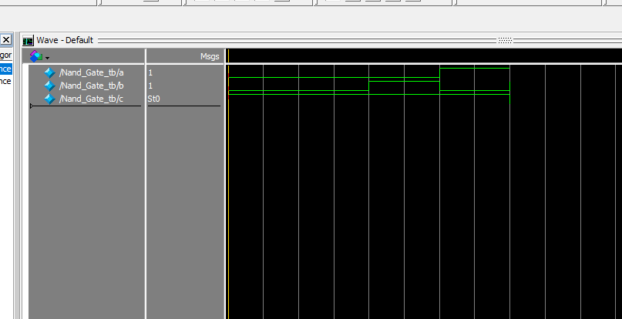
NOR GATE:
A NOR gate is a universal logic gate. It produces output 1 (HIGH) only when all inputs are 0. If any input is 1, the output will be 0.
It is the complement of the OR gate.
Truth Table (2-input NOR Gate)
A | B | Y = (A | B)′
0 | 0 | 1
0 | 1 | 0
1 | 0 | 0
1 | 1 | 0
VERILOG CODE OF NOR GATE:
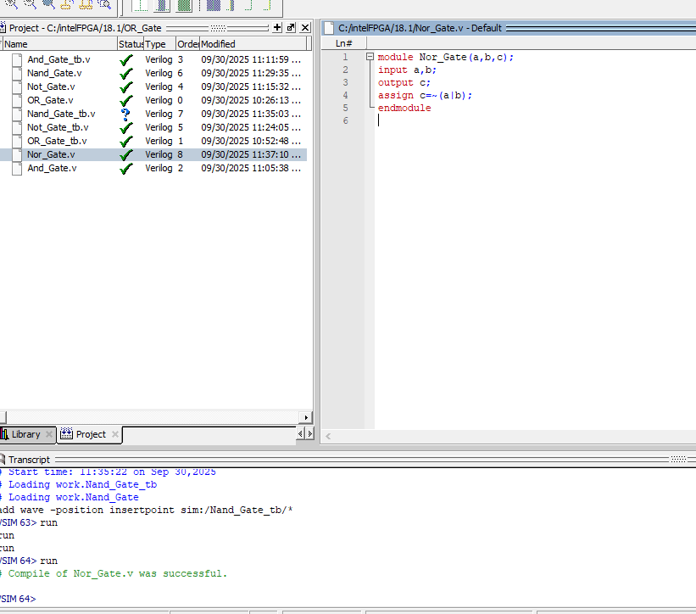SIMULATION OF VERILOG OF NOR GATE:

TESTBENCH CODE OF NOR GATE:
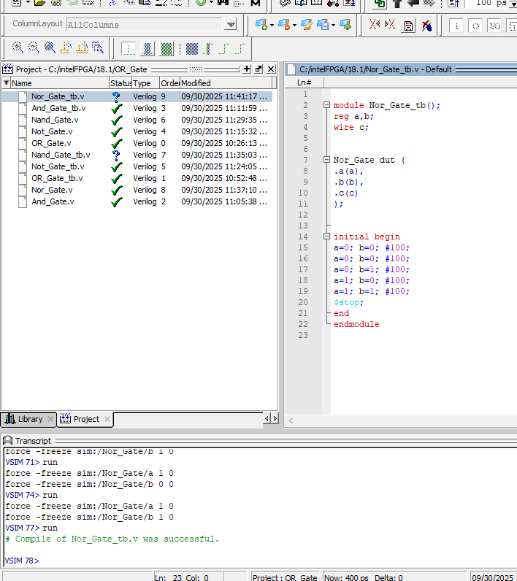
SIMULATION OF TESTBENCH OF NOR GATE:

